Assignment No 3&4



Fall 2022

**CSE-208 OOP**

Submitted by: MUHAMMAD SADEEQ

Registration No.: 21PWCSE2028

Section: C

“On my honor, as a student of the University of Engineering and Technology, I have neither given nor received unauthorized assistance on this academic work”

Submitted to:

Dr. Nasru-Minallah

(19 Jan 2023)

Department of Computer systems engineering

University of Engineering and Technology, Peshawar

**ASSIGNMENT NO 3**

**CODE:**

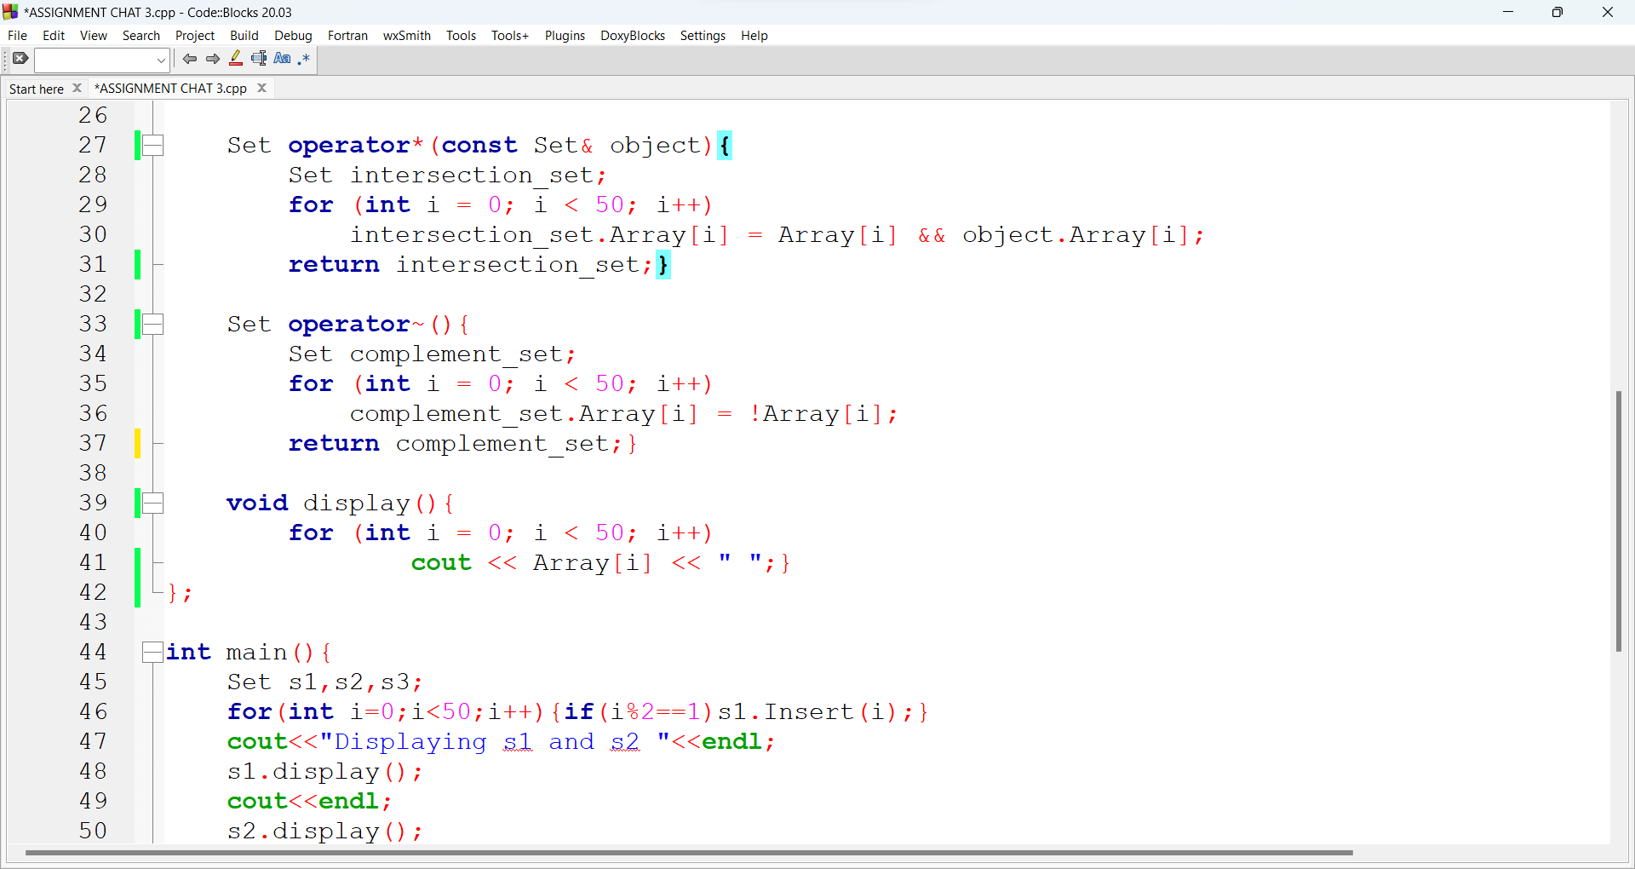

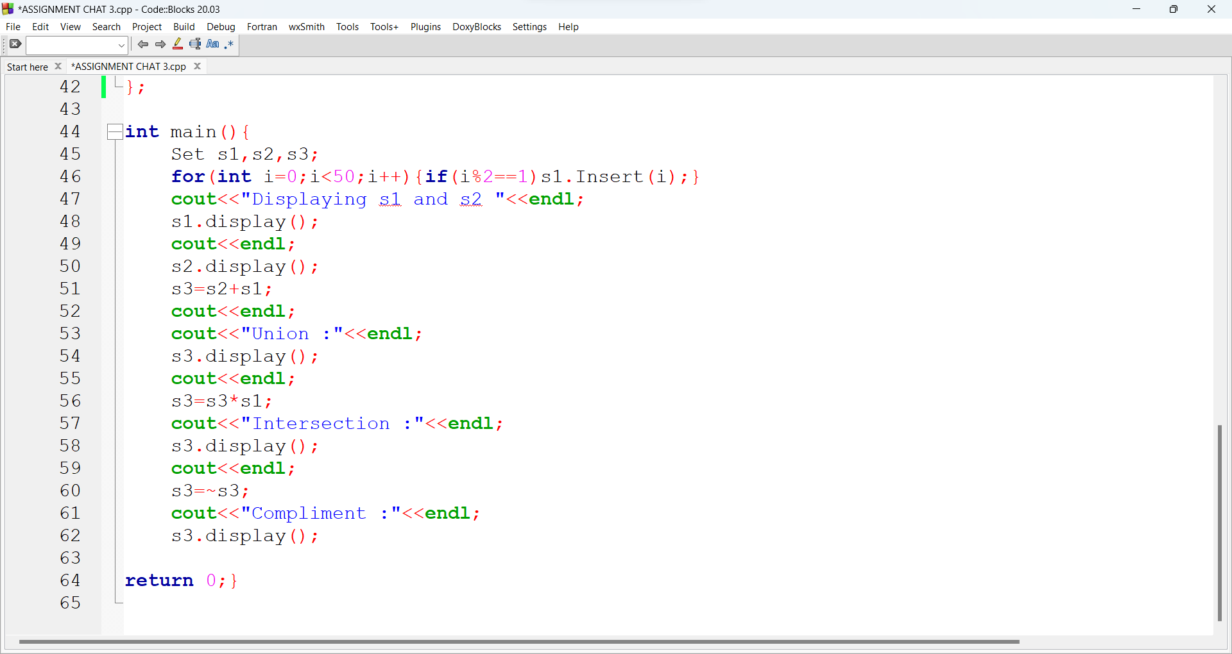

**Answer (1)** I made no argument constructor in the class and initialize the elements of array to zero by for loop from 0 to 49 index.

**Answer (2)** I wrote a insert function having single int argument it will take index of array and set that index element to 1

**Answer (3)** I copy insert function and change name to remove and set the value to zero.

**Answer (4)** I wrote an overloaded operator + function and took OR of both arrays

**Answer (5)** I wrote an overloaded operator * function and took AND of both arrays

**Answer (6)** I wrote an overloaded operator ~ function and took NOT of the given array

**ASSIGNMENT NO 4**

**CODE:**

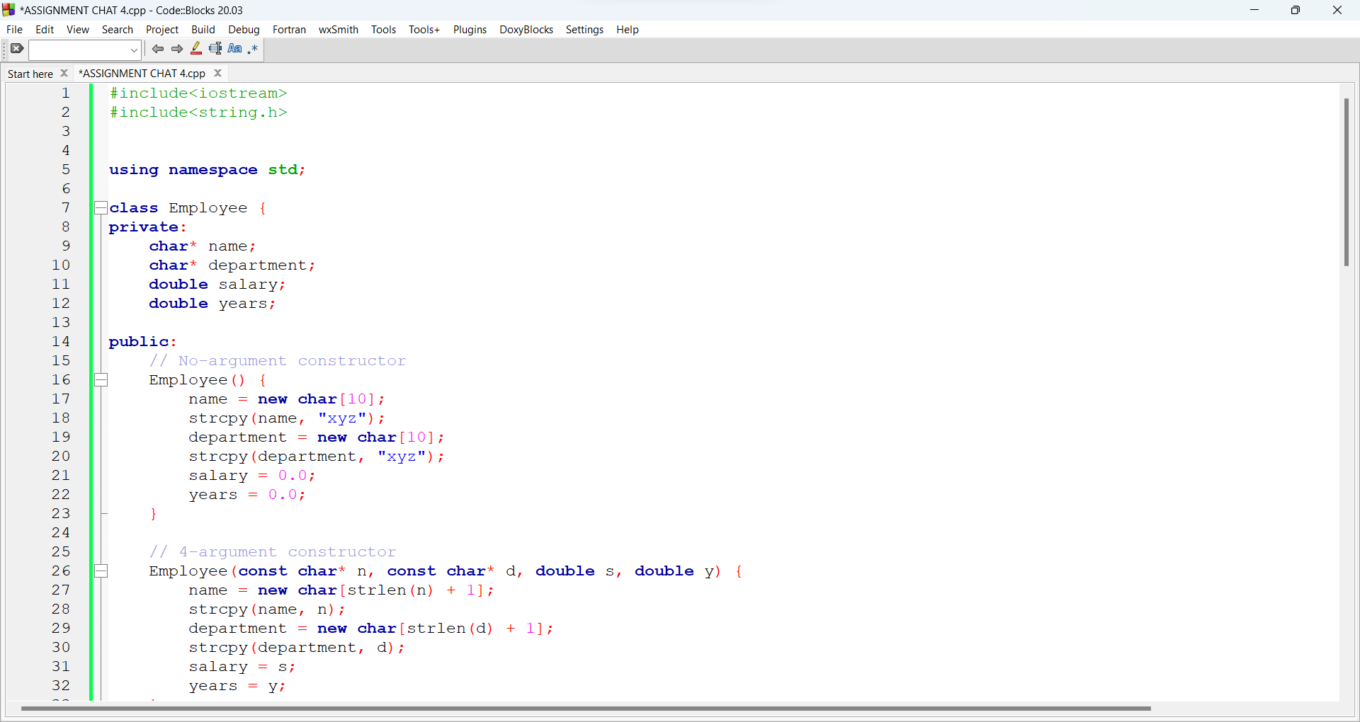

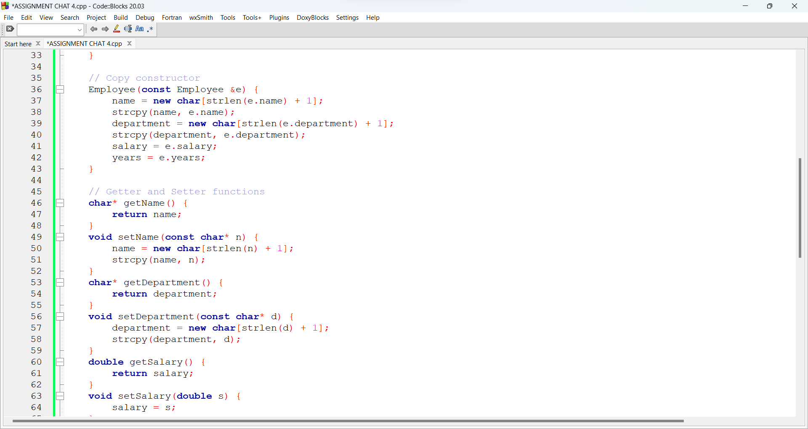

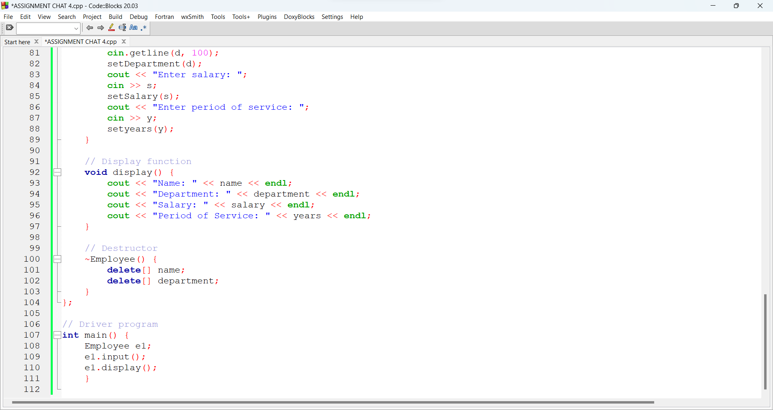

**Answer (1)** I wrote no argument constructor and initialize the data members to fix values

**Answer (2)**I wrote 4 argument constructor did dynamic allocation for both pointers

**Answer (3)**I wrote a copy constructor did dynamic allocation for both pointers and did deep copy

**Answer (4)** I wrote separate getter and setter functions for each data member

**Answer (5)** iwrote input function that will take all values during run time.i use getline for name and department and cin for salary and years.

**Answer (6)** IMade display function will display all data of specific student.

**Answer (7)** IMade a destructor to free memory of name and department

**Answer (8)** Then made main function to test the class.